**6 days Marangu route Kilimanjaro climbing**

Known as the “Coca-Cola” route, the Marangu route is a classic trek on Mount Kilimanjaro. It is the oldest, most well established route. Many favour the Marangu route because it is considered to be the easiest path on the mountain, due to its more gradual slope. It is also the only route which offers sleeping huts with dormitory style accommodation. There are 60 bunk beds at both Mandara and Kibo Huts, and 120 bunk beds at Horombo Hut. Guests are supplied with mattresses and pillows, but sleeping bags are still required. The huts have communal dining halls and basic washrooms, ranging from flushing toilets and running water at the lower huts to long drop toilets and buckets of water at Kibo Hut.

**Day 1(20th July) : Drive to Kilimanjaro National Park Marangu Gate, Hike to Mandara Hut**

After breakfast and briefing, drive to the Kilimanjaro National Park Gate (about 1 hour), register and commence the trek. Walk through the rainforest to the Mandara Huts. A side trip to Maundi Crater is a good way to see the surroundings including Northern Tanzania and Kenya. In the rainforest, look for towering Eucalyptus trees, bird life, and Colobus monkeys.

• Elevation: 1860m/6100ft to 2700m/8875ft  
• Distance: 8km/5mi  
• Hiking Time: 3-4 hours  
• Habitat: Montane Forest  
• Meals: LD  
• Budget Lodging: Mandara Hut

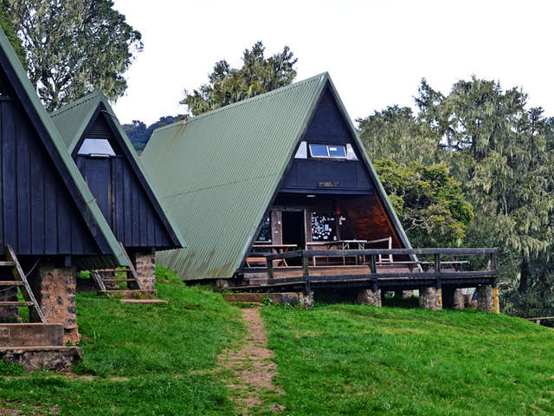

**Day 2(21st July) : Hike Mandara Hut to Horombo Hut**

You leave the glades of the rain-forest and follow an ascending path on the open moorlands to the Horombo Huts. Views of Mawenzi and the summit of Kibo are amazing. Look for giant lobelias and grounsels. You may begin to feel the affects of the altitude.

• Elevation: 2700m/8875ft to 3700m/12,200ft  
• Distance: 12km/7.5mi  
• Hiking Time: 5-6 hours  
• Habitat: Heathland  
• Meals: BLD  
• Budget Lodging: Horombo Hut

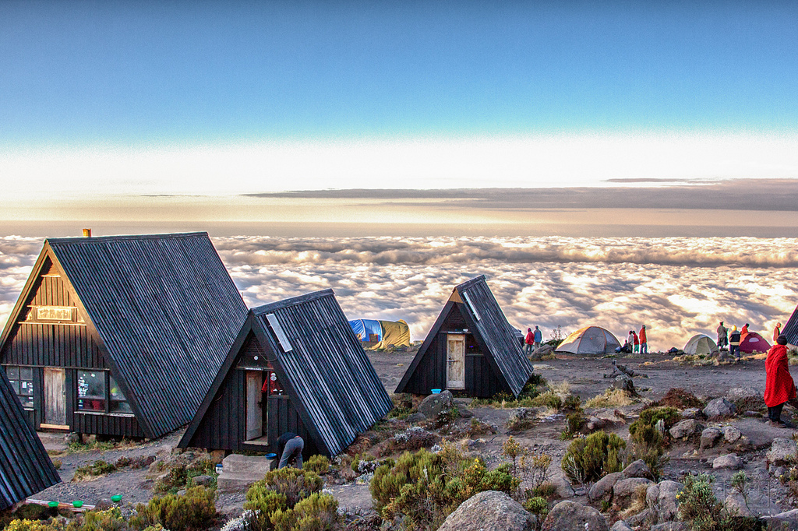

**Day 3(22nd July) : Rest Day at Horombo Hut**

Rest day at Horombo Hut with optional hike by Mawenzi Peak.

• Meals: BLD  
• Budget Lodging: Horombo Hut

**Day 4(23rd July) : Hike Horombo Hut to Kibo Hut**

Ascending, we now pass the last watering point, walking onto the saddle of Kilimanjaro between the peaks of Kibo and Mawenzi. Vegetation begins with upper heath-land but then disappears into “moonscape”. Dinner, rest, and prepare for summit climb.

• Elevation: 3700m/12,200ft to 4700m/15,500ft  
• Distance: 9km/5.5mi  
• Hiking Time: 5-6 hours  
• Habitat: Alpine Desert  
• Meals: BLD  
• Budget Lodging: Kibo Hut

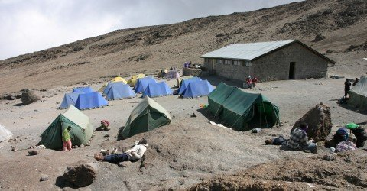

**Day 5(24th July) : Hike Kibo Hut to Summit, and down to Horombo Hut**

Very early in the morning (midnight to 2am), commence the climb to the summit on steep and heavy scree or snow up to Gilman’s point located on the crater rim. Continuing, we now ascend to Uhuru Peak, which is the highest point in Africa. There are unbelievable views at every turn. Have your picture taken at the summit to show your friends and family. From here we descend, stopping for lunch and a rest at Kibo before continuing on to the Horombo Huts.  
The beginning of this climb is done in the dark and requires headlamps or flashlights. It will be very cold until you start descending, so you will need all of your warm layers. This is by far the most difficult part of the trek with many switchbacks. Going slowly “pole pole” and an optimistic attitude will get you there!

• Elevation: 4700m/15,500ft to 5895m/19,340ft  
• Down to 3700m/12,200ft  
• Distance: 6km/4mi up / 15km/9mi down  
• Hiking Time: 6-8 hours up / 15km/9mi down  
• Habitat: Alpine Desert  
• Meals: BLD  
• Budget Lodging: Horombo Hut

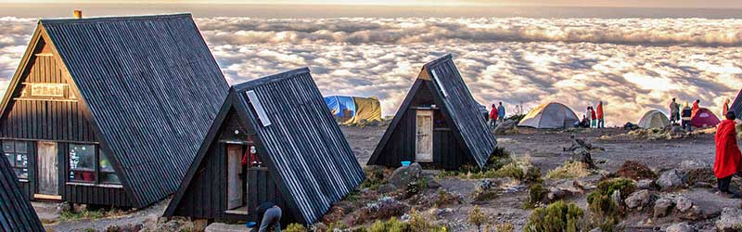

**Day 6(25th July) : Hike Horombo Hut to trail head, drive to Moshi**

After breakfast, a steady descent takes us down through moorland to the Mandara Hut. Continue descending through lush forest path to the National Park gate at Marangu. At lower elevations, it can be wet and muddy. Gaiters and trekking poles will help. Shorts and t-shirts will probably be plenty to wear (keep rain gear and warmer clothing handy).  
Sayari Tano Tours & Safaris vehicle will meet you at Marangu gate to drive you back to your to the Arusha Moshi

• Elevation: 3700m/12,200ft to 1700m/5500ft  
• Distance: 20km/12.5mi  
• Hiking Time: 4-5 hours  
• Habitat: Forest  
• Meals: B

**Includes**

* Quality, waterproof, four-season private mountain sleeping tents
* 2 Nights’ accommodation the day before and after your trekking
* Professional, experienced, mountain guides:
* All Park fees
* Rescue fees
* All meals while on the Mountain
* Arrival and Departure transfers
* Guides, Porters, cook salaries and park fees
* Quality Mess tents with table and chairs:
* Large portions of fresh, healthy, nutritious food:
* Clean, purified drinking water:
* Crisis management and safety procedures:
* Fair and ethical treatment of porters:

**Excludes:**

* Tanzania Visa: $50 per person on arrival
* Personal Expenses (e.g. laundry, telephone, beverages, etc.)
* Travel insurance
* Tips and any items of personal nature.
* Mountain equipment.

What to bring  
• Clothes.  
• A warm sweater as the nights can be chilly at high altitudes.  
• Comfortable shoes