**6 Days Machame Route Kilimanjaro Climbing**

If Marangu is the “Coca Cola” route, then the Machame Route is the “Whiskey” route. It is the second most popular and one of the most scenic routes on the mountain.

All climbers sleep in tents (tents are included) and meals are served in a dinner tent or on a blanket outside.

It is done over 6 days, so acclimatization is easier, and the success rate is fairly high. It is for physically fit people with some hiking experience. Descent is down the Mweka trail staying at the Mweka or Millennium camp the final night on the mountain.

**Day 1: Drive to Kilimanjaro National Park Machame Gate, Hike to Machame Camp**

Drive from Moshi to Machame Gate takes about 45 minutes. The journey passes through the village of Machame which is located on the lower slopes of the mountain.

We depart the park gate and walk through the rain forest on a winding trail up a ridge. At lower elevations the trail can be muddy and slippery. Gaiters and trekking poles are a good idea here. We continue a short distance until we reach the Machame Camp.

* Elevation: 1830m/6000ft to 3050m/9950ft
* Distance: 11km/7mi
* Hiking Time: 5-6 hours
* Habitat: Montane Forest
* Meals: LD

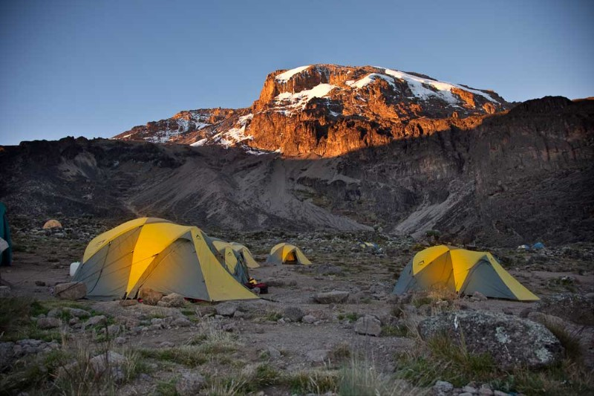 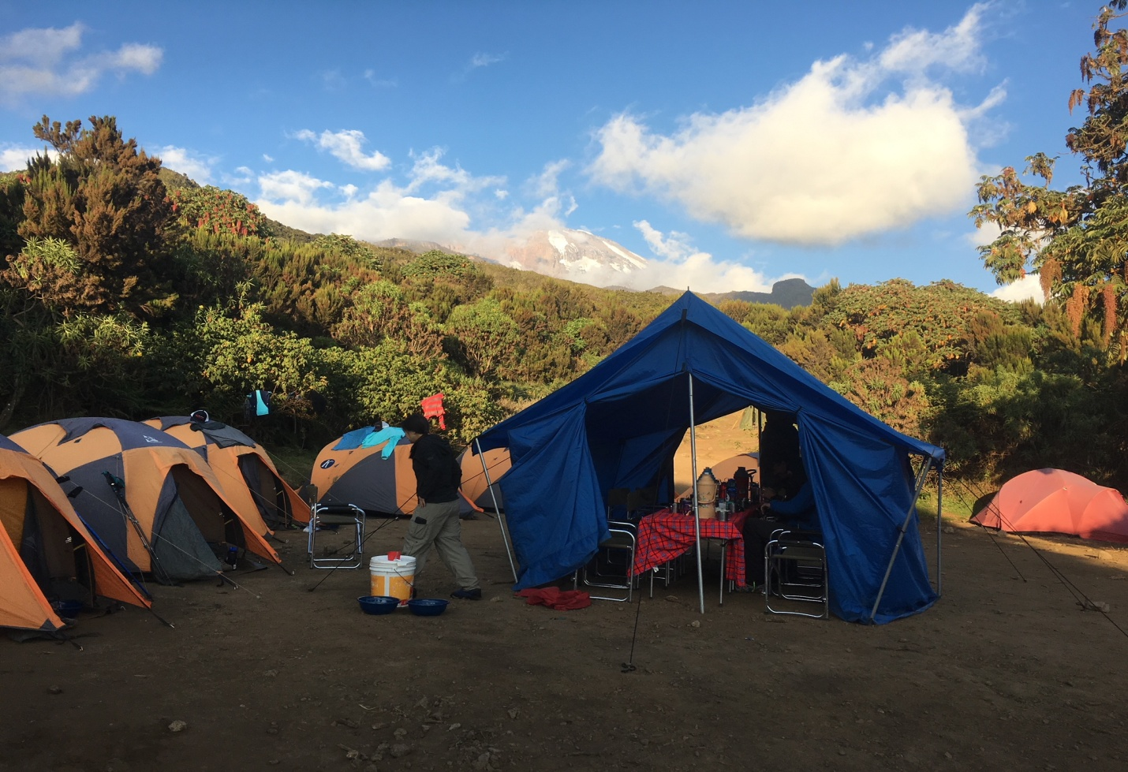

**Day 2: Machame Camp to Shira Camp**

After breakfast we leave the glades of the rain forest and continue on an ascending path, crossing the valley along a steep rocky ridge. The route now turns west onto a river gorge until we arrive at the Shira campsite.

* Elevation: 3050m/9950ft to 3850m/12,600ft
* Distance: 5km/3mi
* Walking Time: 4-5 hours
* Habitat: Moorland
* Meals: BLD

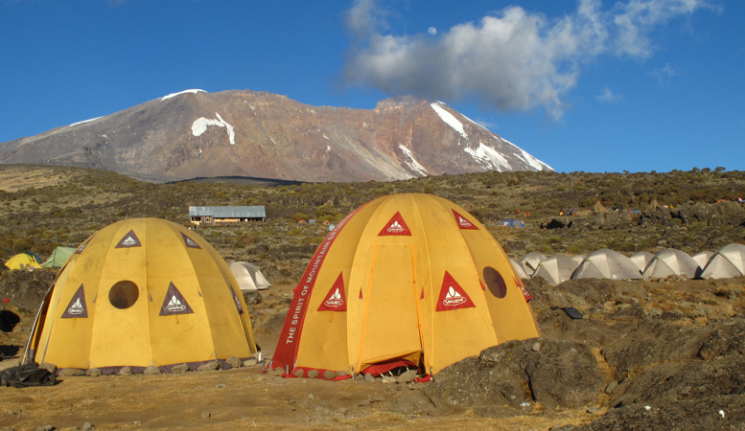

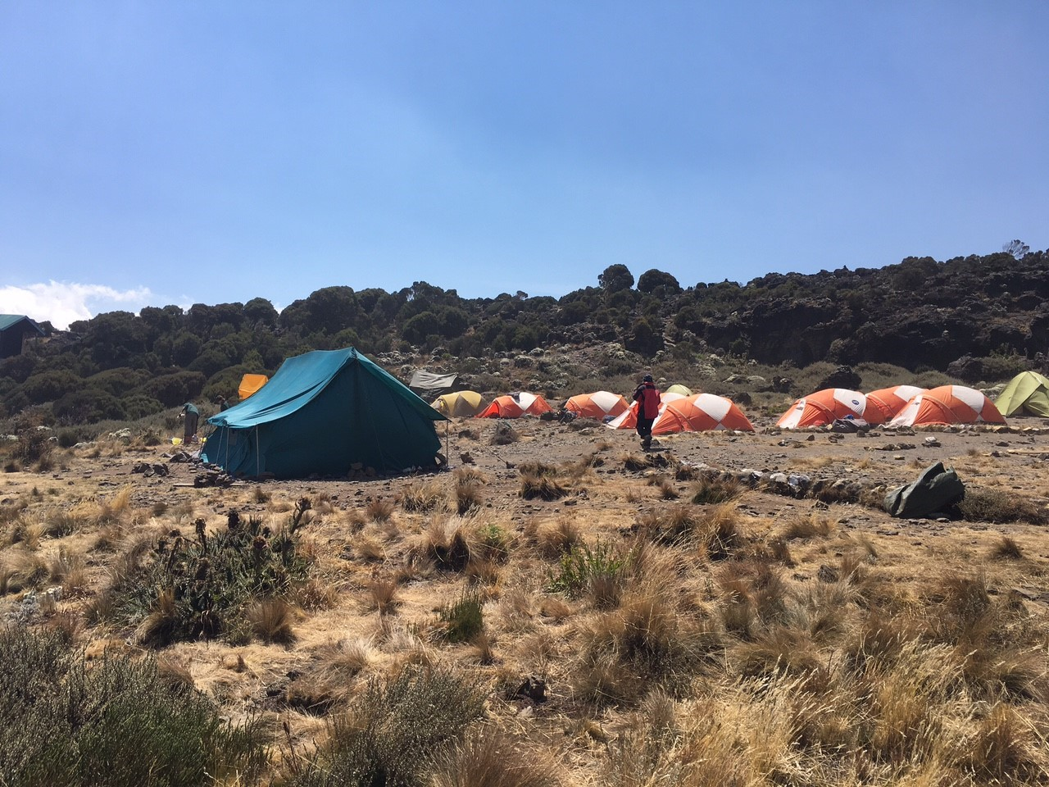

**Day 3: Shira Camp to Lava Tower to Barranco Camp**

From the Shira Plateau we continue to the east up a ridge, passing the junction towards the peak of Kibo. As we continue, our direction changes to the South East towards the Lava Tower, called the “Shark’s Tooth” (elev 4650m/15,250ft). Shortly after the tower we come to the second junction which goes to the Arrow Glacier. We now continue down to the Barranco Camp. Although you end the day around the same elevation as when you began, this day is very important for acclimatization and will help your body prepare for summit day.

* Elevation: 3850m/12,600ft to 4000m/13,000ft
* Distance: 10km/6mi
* Walking Time: 5-6 hours
* Habitat: Semi-desert
* Meals: BLD

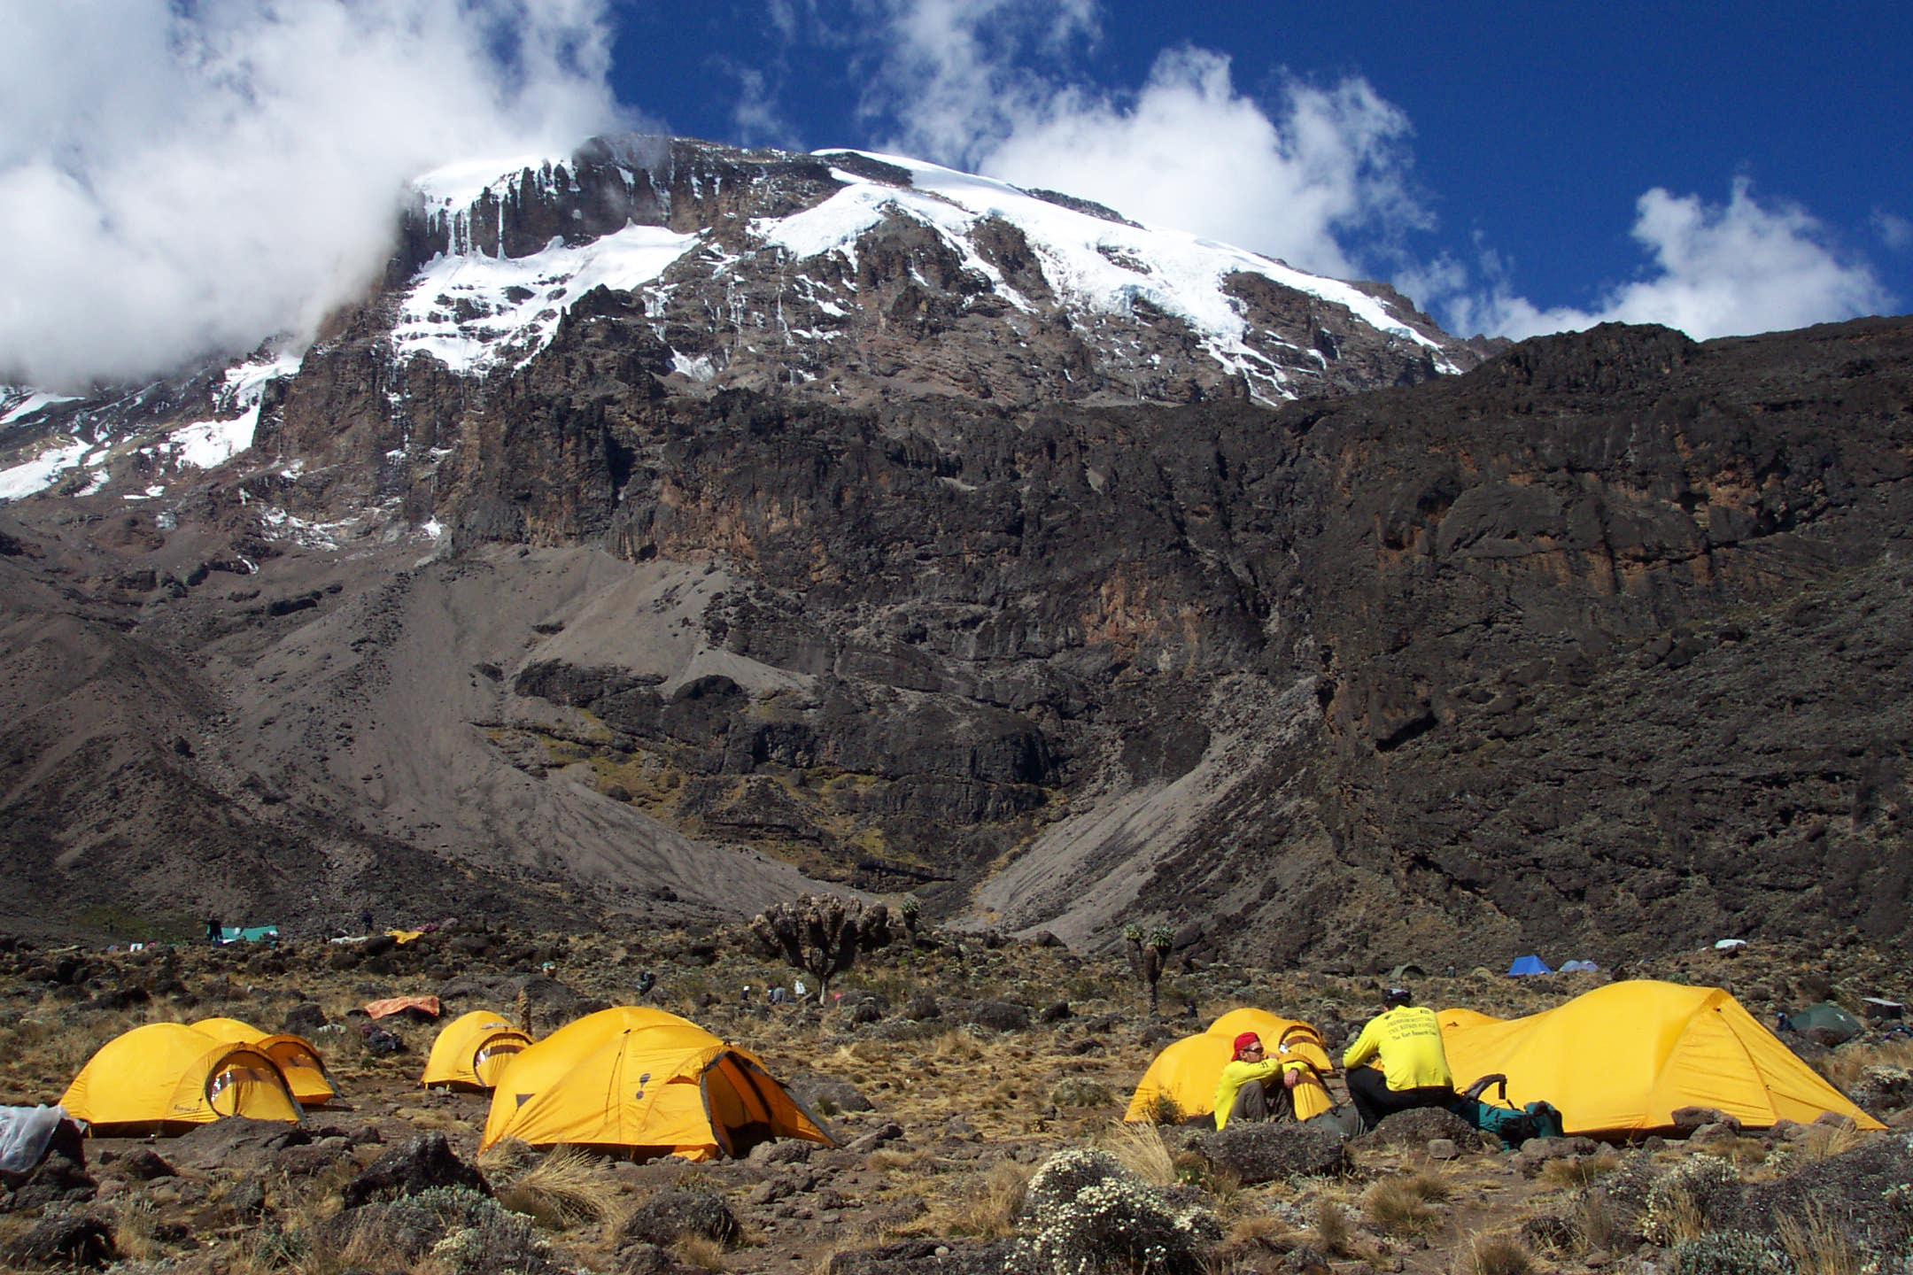

**Day 4: Barranco Camp to Barafu Camp**

After breakfast, we leave Barranco and continue on a steep ridge up the Barranco Wall (elev 4250m/13,900ft), through the Karanga Valley (elev 4050m/13,250ft) to the junction which connects with the Mweka Trail. We continue up to the Barafu Camp. You have completed the South Circuit, which offers views of the summit from many different angles. Here we make camp with views of the summit in the distance.

* Elevation: 4000m/13,000ft to 4700m/15,350ft
* Distance: 9km/6mi
* Hiking Time: 6-8 hours
* Habitat: Alpine Desert
* Meals: BLD

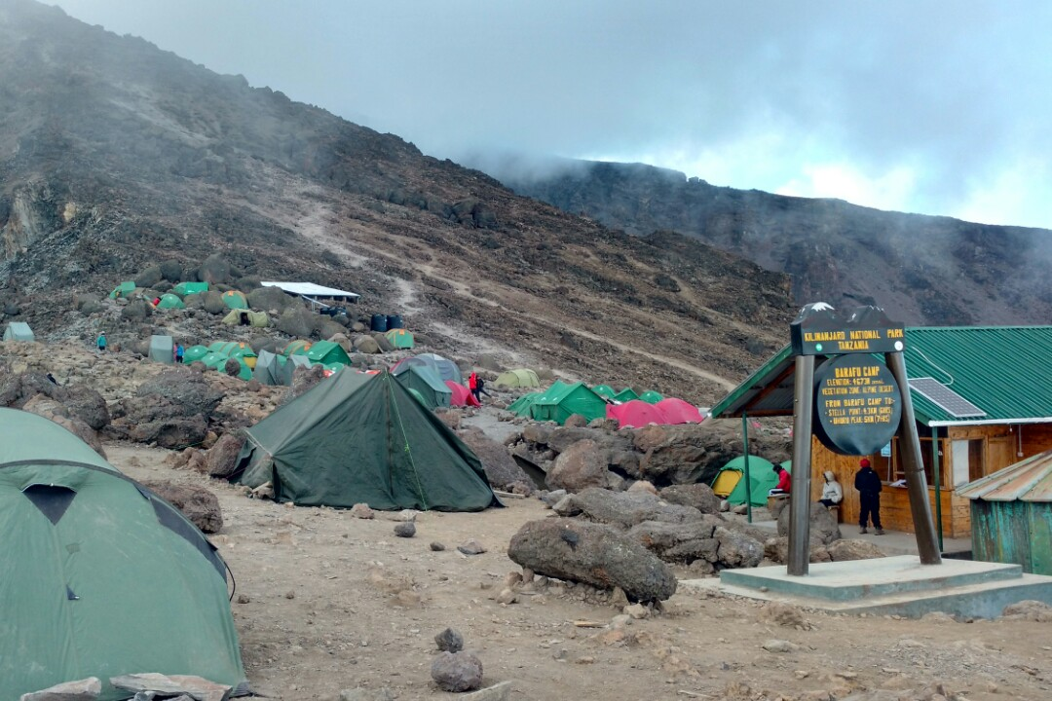

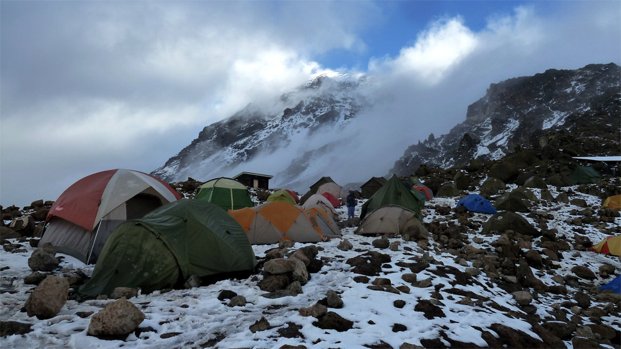

**Day 5: Barafu Camp to Summit, down to Mweka Camp**

Very early in the morning (midnight to 2 am), we continue our way to the summit between the Rebmann and Ratzel glaciers. You head in a northwesterly direction and ascend through heavy scree towards Stella Point on the crater rim. This is the most mentally and physically challenging portion of the trek. At Stella Point you will stop for a short rest and will be rewarded with the most magnificent sunrise you are ever likely to see. Faster hikers may view the sunrise from the summit.

From Stella Point, you may encounter snow all the way on your 1-hour ascent to the summit. Once at Uhuru Peak you have reached the highest point on Mount Kilimanjaro and the continent of Africa!

From the summit we begin our descent by continuing straight down to the Mweka Camp, stopping at Barafu for lunch. You may want gaiters and trekking poles for the loose gravel going down. We arrive at Mweka Camp and enjoy our last evening on the mountain.

* Elevation: 4700m/15,350ft to 5895m/19,340ft
* Down to 3090m/10,150ft
* Distance: 5km/3mi up / 13km/8mi down
* Hiking Time: 5-7 hours up / 5-6 hours down
* Habitat: Stone scree and ice-capped summit
* Meals: BLD

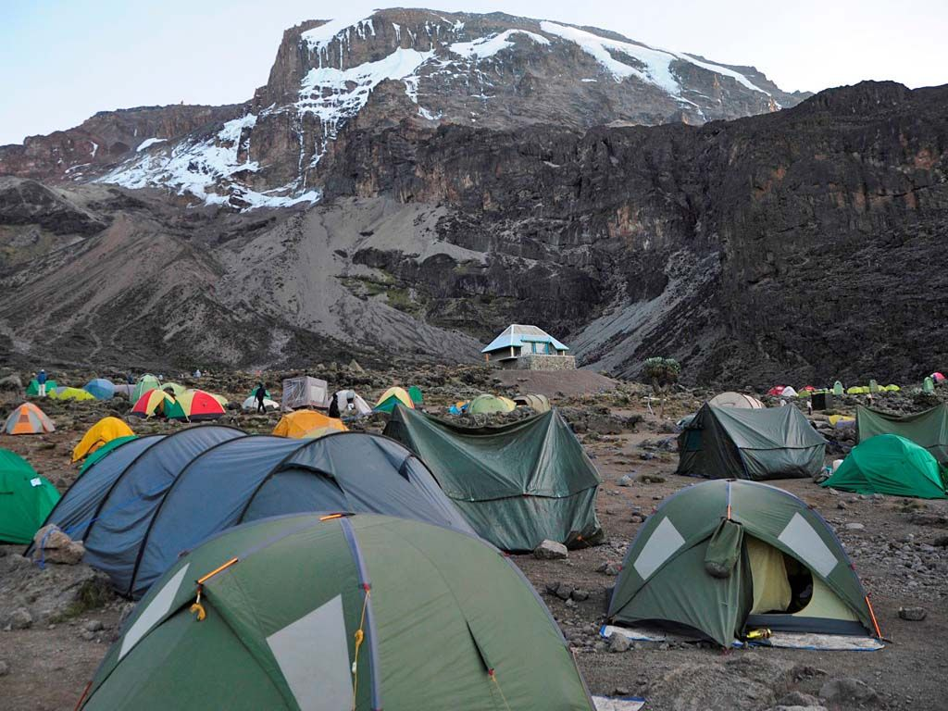

**Day 6: Mweka Camp to Mweka Gate, drive to Moshi**

After breakfast we continue the descent down to the Mweka Park Gate to receive your summit certificates. At lower elevations, it can be wet and muddy. Gaiters and trekking poles will help. Shorts and t-shirts will probably be plenty to wear (keep rain gear and warmer clothing handy).

Elevation: 3090m/10,150ft to 1680m/5500ft

* Distance: 10km/6mi
* Hiking Time: 3-4 hours
* Habitat: Forest
* Meals: B

Foot Slopes Tours & Safaris vehicle will be waiting for you at Mweka gate to drive you back to your Arusha

**Includes**

* Quality, waterproof, four-season private mountain sleeping tents
* 2 Nights’ accommodation the day before and after your trekking
* Professional, experienced, mountain guides:
* All Park fees
* Rescue fees
* All meals while on the Mountain
* Arrival and Departure transfers
* Guides, Porters, cook salaries and park fees
* Quality Mess tents with table and chairs:
* Large portions of fresh, healthy, nutritious food:
* Clean, purified drinking water:
* Crisis management and safety procedures:
* Fair and ethical treatment of porters:

**Excludes:**

* Tanzania Visa: $50 per person on arrival
* Personal Expenses (e.g. laundry, telephone, beverages, etc.)
* Travel insurance
* Tips and any items of personal nature.
* Mountain equipment
* Sleeping Mattress:

What to bring  
• Clothes.  
• A warm sweater as the nights can be chilly at high altitudes.  
• Comfortable shoes