**5 days Marangu Route Kilimanjaro Trekking**

Marangu Route is also known as the “Coca Cola” or “tourist” route. It is the easiest and shortest route to the summit. This is also the only route with the comforts of sleeping huts at every camp site with solar lights and comfortable beds. The huts are communal, and the bunks have a sponge mattress and pillow.

There are 60 beds at both Mandara and Kibo Huts and 120 beds at Horombo Hut. Bathrooms and running water are available at the two lower huts. Mens’ and ladies’ latrines are available at the last camp but are very basic.

This route is usually done in 5 days but can be done in 6 days for better acclimatization. The extra day can be spent resting at Horombo or climbing the small peak of Mawenzi.

**Day 1: Drive to Kilimanjaro National Park Marangu Gate, Hike to Mandara Hut**

After breakfast and briefing, drive to the Kilimanjaro National Park Gate (about 1 hour), register and commence the climb. Walk through the rainforest to the Mandara encampment. A side trip to Maundi Crater is a good way to see the surroundings including Northern Tanzania and Kenya. In the rainforest, look for towering Eucalyptus trees, bird life, and Colobus monkeys.

* Elevation: 1860m/6100ft to 2700m/8875ft
* Distance: 8km/5mi
* Hiking Time: 3-4 hours
* Habitat: Montane Forest
* Meals: LD

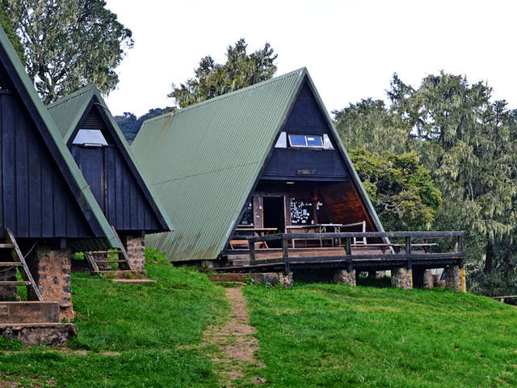

**Day 2: Hike Mandara Hut to Horombo Hut**

You leave the glades of the rain-forest and follow an ascending path on the open moorlands to the Horombo encampment. Views of Mawenzi and the summit of Kibo are amazing. Look for giant lobelias and grounsels. You may begin to feel the affects of the altitude.

* Elevation: 2700m/8875ft to 3700m/12,200ft
* Distance: 12km/7.5mi
* Hiking Time: 5-6 hours
* Habitat: Heathland
* Meals: BLD

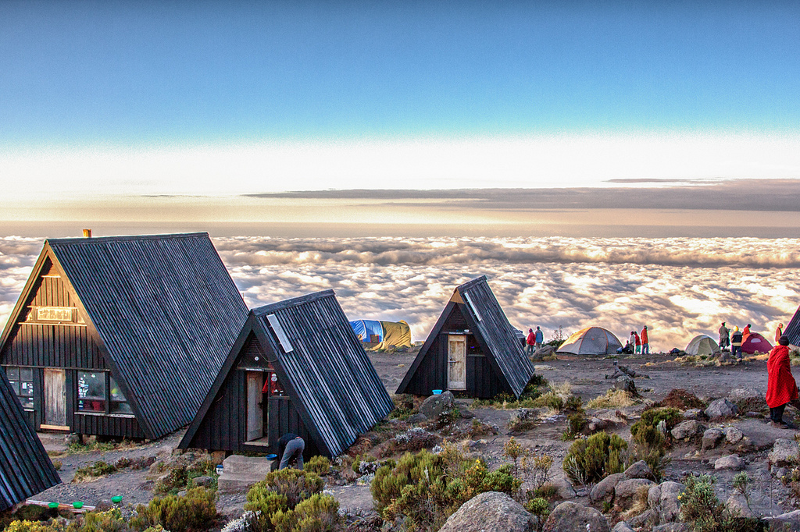

**Day 3 : Hike Horombo Hut to Kibo Hut**

Ascending, we now pass the last watering point, walking onto the saddle of Kilimanjaro between the peaks of Kibo and Mawenzi. Vegetation begins with upper heathland but then disappears into “moonscape”. Dinner, rest, and prepare for summit climb.

* Elevation: 3700m/12,200ft to 4700m/15,500ft
* Distance: 9km/5.5mi
* Hiking Time: 5-6 hours
* Habitat: Alpine Desert
* Meals: BLD

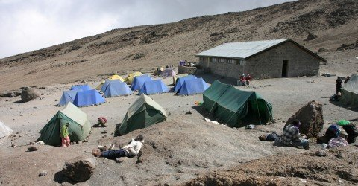

**Day 4: Hike Kibo Hut to Summit, and down to Horombo Hut**

Very early in the morning (midnight to 2 am), commence the climb to the summit on steep and heavy scree or snow up to Gilman’s point located on the crater rim. Continuing, we now ascend to Uhuru Peak, which is the highest point in Africa. There are unbelievable views at every turn. Have your picture taken at the summit to show your friends and family. From here we descend, stopping for lunch and a rest at Kibo before continuing on to the Horombo encampment.

The beginning of this climb is done in the dark and requires headlamps or flashlights. It will be very cold until you start descending, so you will need all of your warm layers. This is by far the most difficult part of the trek with many switchbacks. Going slowly “pole pole” and an optimistic attitude will get you there!

* Elevation: 4700m/15,500ft to 5895m/19,340ft
* Down to 3700m/12,200ft
* Distance: 6km/4mi up / 15km/9mi down
* Hiking Time: 6-8 hours up / 15km/9mi down
* Habitat: Alpine Desert
* Meals: BLD

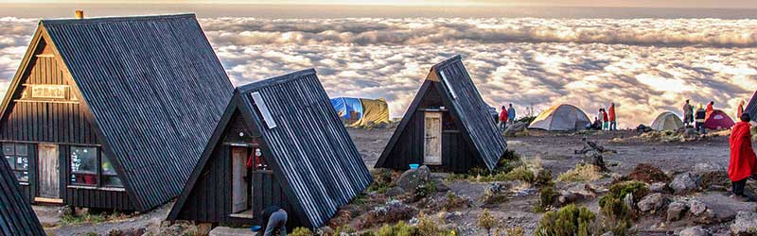

**Day 5: Hike Horombo Hut to trail head, drive to Moshi**

After breakfast, a steady descent takes us down through moorland to the Mandara Hut. Continue descending through lush forest path to the National Park gate at Marangu. At lower elevations, it can be wet and muddy. Gaiters and trekking poles will help. Shorts and t-shirts will probably be plenty to wear (keep rain gear and warmer clothing handy).

A vehicle will be waiting for you at Marangu gate to drive you back to your at Arusha for overnight

At the last night of your trekking we will drop off you at the airport

* Elevation: 3700m/12,200ft to 1700m/5500ft
* Distance: 20km/12.5mi
* Hiking Time: 4-5 hours
* Habitat: Forest
* Meals: B

**Includes**

* Quality, waterproof, four-season private mountain sleeping tents
* 2 Nights’ accommodation the day before and after your trekking
* Professional, experienced, mountain guides:
* All Park fees
* Rescue fees
* All meals while on the Mountain
* Arrival and Departure transfers
* Guides, Porters, cook salaries and park fees
* Quality Mess tents with table and chairs:
* Large portions of fresh, healthy, nutritious food:
* Clean, purified drinking water:
* Crisis management and safety procedures:
* Fair and ethical treatment of porters:

**Excludes:**

* Tanzania Visa: $50 per person on arrival
* Personal Expenses (e.g. laundry, telephone, beverages, etc.)
* Travel insurance
* Tips and any items of personal nature.
* Mountain equipment
* Sleeping Mattress

What to bring  
• Clothes.  
• A warm sweater as the nights can be chilly at high altitudes.  
• Comfortable shoes